**The Effect of Indwelling Arterial Catheters in Hemodynamically Stable Patients With Respiratory Failure**

Douglas J Hsu, MD* (1, 2), Mengling Feng, PhD* (3, 5), Rishi Kothari, MD (4), Hufeng Zhou(6), Leo A. Celi, MD MS MPH (1, 3)

1. Division of Pulmonary, Critical Care, and Sleep Medicine, Beth Israel Deaconess Medical Center, Boston, MA
2. Division of Pulmonary and Critical Care, Massachusetts General Hospital, Boston MA
3. Laboratory of Computational Physiology, Massachusetts Institute of Technology, Cambridge, MA
4. Department of Anesthesia, Mount Sinai Hospital, New York, NY
5. Institute for Infocomm Research, Singapore
6. Brigham and Women's Hospital, MA

* These authors contributed equally in this work.

**Corresponding Author**

Douglas Hsu, MD

Bullfinch 148

55 Fruit Street

Boston, MA 02214

[dhsu@bidmc.harvard.edu](mailto:dhsu@bidmc.harvard.edu)

(617) 667-5864

(888) 314-5895

**Author Contributions:**

Conception and Design: DH, LC, MF

Analysis, Data collection, and Interpretation: DH, MF, RK, LC

Drafting Manuscript: DH, MF, RK, LC

**Sources of Support:**  National Institute of Biomedical Imaging and Bioengineering grant R01 EB001659. Dr. Feng’s fellowship is supported by A*STAR Graduate Scholarship.

**Running Head:**

**Descriptor:**

**Word Count:**

**Impact this Research will have on Clinical Medicine:**

**ABSTRACT**

**Rationale**: Indwelling arterial catheters (IACs) are used extensively in the Intensive Care Unit (ICU) for continuous hemodynamic monitoring and for arterial blood gas analysis. The use of IACs in the ICU setting is widespread, occurring in approximately 30% of ICU patients, resulting in 6-8 million arterial catheters placed annually in the United States. IACs pose potentially serious risks, including blood stream infections and vascular complications. The purpose of this study is to assess whether the presence of IACs affects 28-day mortality in hemodynamically stable, mechanically ventilated patients.

**Objectives:** The purpose of this study is to assess whether the presence of IACs improves outcomes in mechanically ventilated patients who do not require vasopressor support.

**Methods:** This study used the Multiparameter Intelligent Monitoring in Intensive Care II (MIMIC-II) database, a publicly available database of 24,581 patients admitted to the Beth Israel Deaconess Medical Center ICU between 2001 and 2008. Patient selection criteria included endotracheal intubation and mechanical ventilation within the first 24 hours of ICU admission, no IAC placement prior to ICU admission, no evidence of sepsis, and no vasopressor requirement. We developed a model based on patient demographics, co-morbidities, vital signs, and laboratory results to estimate the propensity for IAC placement for this study cohort. Patients with or without IACs were then matched based on the estimated propensity scores using a one-to-one matching with a caliper of 0.01. The Fisher’s exact test was used to assess measures of association between IAC utilization and 28-day mortality for the matched cohort.

**Results:** We identified 1,776 ICU patients with hemodynamically stable respiratory failure, for which 984 (55.4%) underwent IAC placement. There were 696 IAC-non IAC matched patients. Based on a 10-fold cross-validation, the proposed multivariable regression of propensity for IAC placement had a c-statistic of 0.81. There was no difference in 28-day mortality in the IAC group (14.7%) and the non-IAC group (15.2%; p = 0.9). In patients that survived to discharge, duration of mechanical ventilation was shorter in the non-IAC group as compared to the IAC group (0.75 vs 1.1 days, p<0.001), as were ICU length-of-stay (1.8 vs 2.8 days, p<0.001) and hospital length-of-stay (4 vs 7 days, p<0.001).

**Conclusions:** In mechanically ventilated patients who are hemodynamically stable, the presence of an IAC is not associated with a difference in 28-day mortality after adjustment for the propensity for IAC placement. Further analyses in other critically ill subgroups, as well as validation in additional datasets is warranted. This study is the first of several investigations into the clinical value of various interventions in the management of critically ill patients.

**INTRODUCTION**

Indwelling arterial catheters (IAC) have been used extensively in the Intensive Care Unit (ICU) setting for continuous hemodynamic monitoring and for obtaining arterial blood sampling for arterial blood gas analysis. The use of IACs in the ICU setting is widespread, occurring in approximately 30% of ICU patients (REF), resulting in 6-8 million IAC placed annually in the United States (REF).

Despite the widespread use of IACs, there are small but potentially serious complications that may arise. IAC-associated blood stream infections have been reported at a rate that, while not to the level of central venous catheters, is significantly higher than peripheral venous access. A systematic review of the risk of blood stream infections associated with intravascular catheters reports a pooled point estimate of 1.6 per 1,000 device days (95% CI 1.2,2.3) for IACs compared with 0.5 (95% CI 0.2-0.7) for peripheral venous access, and 2.7 (95% CI 2.6-2.9) for central venous catheters. Additionally, vascular complications associated with IACs are more common than previously thought, including thrombosis, ischemia, hematoma, bleeding, and pseudoaneurysm (REFs). The presence of IACs may promote an increased frequency of blood draws and laboratory testing, including arterial blood gas sampling (REF).

In the context of increased utilization including blood draws and testing as well as potential adverse effects associated with IAC use, there is scant clinical outcome data to support their widespread use. The purpose of this study is to establish in a large cohort of intensive care patients whether the presence of IACs improves outcomes in hemodynamically stable patients with respiratory failure undergoing mechanical ventilation.

**METHODS**

Study Population

We conducted a longitudinal, single center, retrospective cohort study of patients from the Multi Parameter Intelligent Monitoring of Intensive Care (MIMIC-II) database, which includes patients admitted between 2001- 2008. The database contains data from 24,581 ICU patients and includes physiologic information from bedside monitors in the adult ICUs at Beth Israel Deaconess Medical Center, a tertiary care university academic medical center located in Boston, Massachusetts (REF). The data in MIMIC-II has been previously de-identified, and this study was approved by the Institutional Review Boards of the Massachusetts Institute of Technology and Beth Israel Deaconess Medical Center (BIDMC). Additional, a waiver of informed consent has been granted for this study.

The MIMIC-II database was queried to identify adult, who were intubated for the purpose of mechanical ventilation (MV) within the first 24 hours of ICU. **The rationale behind this inclusion criterion is …** Patients were excluded if they had a diagnosis of sepsis based on the Angus criteria [reference] or required vasopressors while in the ICU, as well if IAC placement was performed prior to ICU admission. Patients from the cardiac surgery recovery unit (CSRU) and coronary care unit (CCU) were excluded as well. Additionally, to ensure the independence of data points, only the first ICU admission was included in patients that had multiple ICU admissions. The presence of an IAC was defined as placement of an invasive arterial catheter within 24 hours of initiation of mechanical ventilation.

Outcome Measures:

The primary outcome was 28-day mortality. Secondary outcomes included: ICU and hospital length-of-stay (LOS), duration of mechanical ventilation, and mean number of arterial blood gas measurements performed per day while under MV.

Statistical Analysis

A propensity score model was created to match baseline patient characteristics. 30 of pre-IAC covariates including patient demographics, co-morbidities, vital signs, and pre-intervention laboratory results were used to estimate propensity for IAC insertion for each individual patient. To ensure the robustness of the propensity score model and to avoid overfitting, the goodness-of-fit of the prediction model was evaluated based on the average area under Receiver Operating Characteristics (ROC) curve using 10-fold cross-validation. Patients with or without IAC placement were then matched based on the estimated propensity scores using one-to-one matching with a caliper of 0.01.

We assessed the degree of balance in measured covariates between the IAC and Non-IAC groups by comparing the distributions of categorical and continuous variables. Since the continuous variables were not normally distributed, median values and Inter Quartile Range (IQR) were used to summarize the their distributions. The Fisher’s exact test and Wilcoxon rank-sum test were applied to statistically assess the differences in categorical and continuous variables between the IAC and non-IAC groups. The distributions of the propensity score before and after matching were also compared to further assess the degree of balance.

Analysis of Outcome

For the 28-day mortality primary outcome, the logistic regression model was applied on the matched cohort to estimate the odds ratio and 95% Confidence-Interval (95% CI). Kaplan-Meier estimate of survival was also plotted for the 28-day follow up period, and a p-value was reported using the log rank test.

As mortality is a competing risk with the secondary outcomes (including ICU LOS, total LOS, and duration of mechanical ventilation), … [do we need to use the cumulative incidence function for secondary outcomes?]

**RESULTS**

Of the 22,443 MIMIC-II adult patients’ first ICU admissions reviewed, 8,264 patients from CSRU and CCU were excluded. For the remaining, a total of 5,072 required mechanical ventilation, and a total of 901 met study inclusion criteria. The overall 28-day mortality for the study cohort was XXX%, with an ICU LOS of YYY and duration of mechanical ventilation of ZZZ. The most frequent indication for respiratory failure was XXXX (X%), followed by YYYY (Y%), and ZZZZ (Z%). Based on a 10-fold cross-validation, the proposed multivariable regression of propensity for IAC placement had an area under the Receiver Operating Characteristics (ROC) curve of XXXX (Figure 1). After 1:1 matching, there were XXX patients with respiratory failure who underwent IAC placement and YYY patients with respiratory failure who do no have an IAC placed (Table 1)

Study Outcomes

Table 2 details the primary and secondary study results in the matched cohorts.

Mortality

For the matched cohort, the 28-day mortality for patients with respiratory failure who had a subsequent IAC placed was XXX% versus YYY% in the non-IAC group (p=XXXXX). Similarly, the ICU mortality rate was XXX% in the IAC group and YYY% in the non-IAC group (p=X). Total hospital mortality rates were XX% in the IAC group and Y% in the non-IAC group (Table 2).

Other Secondary Outcomes

Respiratory failure patients who underwent IAC placement had a longer ICU LOS (XXXXX) versus matched patients who did not undergo IAC placement (YYYY, p=X?). The IAC group also had a longer duration of mechanical ventilation (X) compared to their matched cohort (Y, p ?), as well as a greater number of arterial blood gas analyses checked per day.

**DISCUSSION**

In this retrospective cohort study of mechanically ventilated patients who do not require vasopressor support, we report that the placement of an invasive arterial catheter was not associated with an difference in the risk of mortality. Placement of IACs was, however, associated with a longer duration of mechanical ventilation and an increased frequency of arterial blood gas measurements after matching patients for propensity to receive an IAC.

There is a pattern in intensive care medicine that is reflective of the greater medical community, which is to utilize resources without proof of effectiveness. The term used in economics that has been applied to this phenomenon is “demand elasticity.” Jeremy Kahn recently applied this term to the utilization of ICU beds regardless of indication for ICU admission. We would apply the concept of demand elasticity to technology utilization within the ICU. IACs are frequently used in the ICU setting. As is suggested in our analysis, however, a more parsimonious utilization of IACs by restricting the indications for IAC placement may be warranted.

Goal is to identify patient subsets who would benefit and who would be harmed by interventions rather than blanket applying them to entire ICU populations.

A. Biological defense (i.e. why?) –

* Over reliance on data (reacting to clinically insignificant/outcome insignificant microtrends)
* Increase in unmeasured complications rate
* Increase ventilator time is associated with mortality

B. Potential weaknesses to the study include:

* Unmeasured confounding: attempt ot address this by propensity score analysis

Mention use of instrumental variables to examine this further using the much larger Philips database.

* Single center sample: generalizable to other centers, including non-academic and/or community hospitals.

C. Strengths

* Large sample size
* Breadth of measured variables (demographic, outcomes, hemodynamics, lab values, etc)
* Propensity score model to account to balance covariates between cohorts

D. Limitations

* Association not causation
* Unmeasured confounding
* Single center
* Retrospective
* This is hypothesis generating, a reasonable next study would be to perform a randomized controlled trial to evaluate all patients who undergo respiratory failure not on vasopressors. Safety question would be if patients who do not have an arterial line placed but subsequently develop hypotension or shock have worsened outcomes, and this can be addressed in an RCT.

Conclusions

In this single center, retrospective study of mechanically ventilated patients who are hemodynamically stable, the placement of invasive arterial catheters was not associated with a change in mortality as compared to propensity-matched patients without invasive arterial catheters. Invasive arterial catheters were, however, associated with an increased ICU length-of-stay, total length-of-stay, duration of mechanical ventilation, and use of arterial blood gas measurements.

References

Figure 1: Description of Study Design.

Figure 2: Propensity score distribution plot comparing initial and matched scores between IAC and non-IAC groups.

Figure 3: Kaplan-Meier curve of mortality in the propensity matched IAC and non-IAC groups.

Table 1: Baseline covariates between IAC and non-IAC groups in unmatched cohorts and propensity-matched cohorts.

Table 2: Primary and secondary outcomes for propensity-matched IAC and non-IAC groups

Figure 1. Description of Study Design

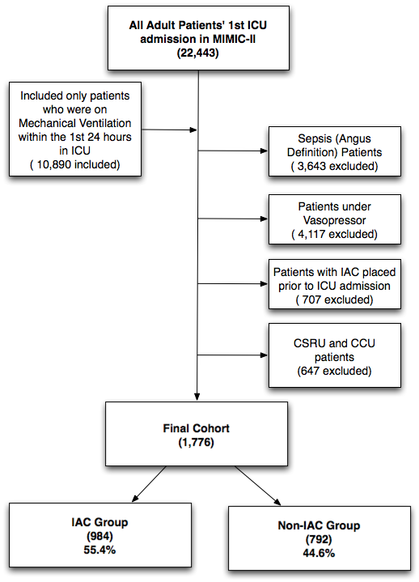

Figure 2. Propensity score distribution plot comparing initial and matched scores between IAC and non-IAC groups. It demonstrates that the propensity matching was successful.

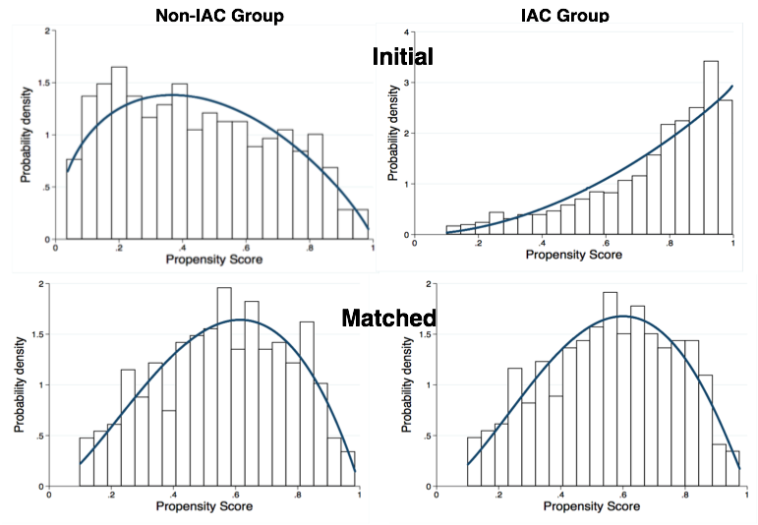

Figure 3. Kaplan-Meier curve of mortality in the propensity-matched IAC and non-IAC groups.

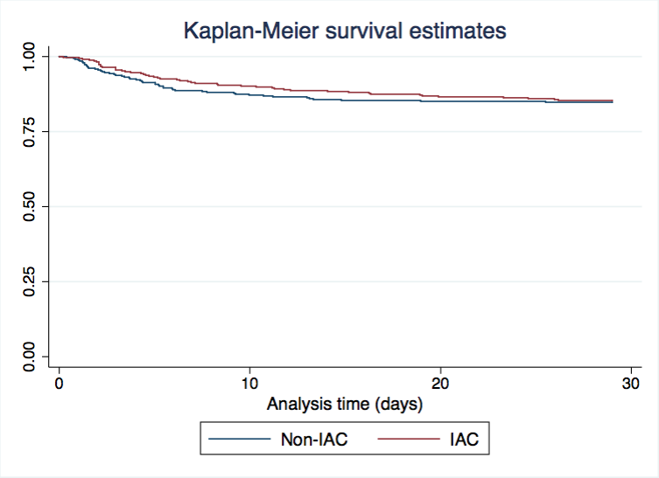

Table 1: Baseline covariates between IAC and non-IAC groups in unmatched and propensity matched cohorts. For continuous variables, the median and Inter-Quartile-Range (IQR) were reported.



|  |  |  |  |  |  |  |
| --- | --- | --- | --- | --- | --- | --- |
| **Variables** | **Entire Cohort (1776)** | | | **Matched Cohort (696)** | | |
| **Non-IAC** | **IAC** | **p-value** | **Non-IAC** | **IAC** | **p-value** |
| **size** | 984 (55.4%) | 792 (44.6%) | NA | 348 (50%) | 348 (50%) | NA |
| **Age (yr.)** | 51 (35~72) | 56 (40~73) | **0.009** | 53 (35~72) | 54 (38~73) | 0.4 |
| **Gender (Female)** | 344 (43.5%) | 406 (41.3%) | 0.36 | 205 (58.9%) | 192 (55.2%) | 0.36 |
| **SOFA Score** | 5 (4~6) | 6 (5~8) | **<0.0001** | 5 (4~7) | 6 (4~7) | 0.6 |
| **Service Unit** |  |  | **<0.0001** |  |  | 0.6 |
| MICU | 504 (63.6%) | 290 (29.5%) | 184 (52.9%) | 192 (55.2%) |
| SICU | 288 (26.4%) | 694 (70.5) | 164 (47.1%) | 156 (44.8%) |
| **Co-morbidities** |  |  |  |  |  |  |
| CHF | 97 (12.5%) | 116 (11.8%) | 0.7 | 44 (12.6%) | 36 (10.3%) | 0.4 |
| A-fib | 82 (10.4%) | 125 (12.7%) | 0.1 | 36 (10.3%) | 32 (9.2%) | 0.7 |
| Renal Disease | 28 (3.5%) | 32 (3.3%) | 0.8 | 13 (3.8%) | 10 (2.9%) | 0.7 |
| Liver Disease | 28 (4.8%) | 61 (6.2%) | 0.2 | 14 (4%) | 18 (5.2%) | 0.6 |
| COPD | 81 (10.23%) | 76 (7.72%) | 0.07 | 32 (9.2%) | 39 (11.2%) | 0.5 |
| CAD | 51 (6.4%) | 72 (7.32%) | 0.5 | 23 (6.6%) | 21 (6%) | 0.8 |
| Stroke | 70 (8.8%) | 152 (15.5%) | **0.0001** | 32 (9.2%) | 33 (9.5%) | 1 |
| Malignance | 92 (11.6%) | 164 (16.7%) | **0.003** | 44 (12.6%) | 51 (14.7%) | 0.6 |
| Respotary Disease | 278 (35.1%) | 287 (29.2%) | **0.008** | 121 (34.7%) | 125 (35.9%) | 0.8 |
| **lab tests** |  |  |  |  |  |  |
| WBC | 10.6 (7.8~14.3) | 11.8 (8.5~15.9) | **<0.0001** | 10.7 (8~14.8) | 11.5 (8.4~14.7) | 0.3 |
| Hemoglobin | 13 (11.3~14.4) | 12.6 (11~14.1) | **0.003** | 12.8 (11.2 ~14.2) | 12.7 (11~14.1) | 0.5 |
| Platelet | 246 (190~304) | 237 (177~294) | 0.01 | 238 (184~303) | 238 (186~289) | 0.7 |
| Sodium | 140 (138~143) | 140 (137~142) | 0.007 | 140 (138~143) | 140 (137~142) | 0.6 |
| Potassium | 4 (3.6~4.5) | 4 (3.7~4.4) | 0.77 | 4 (3.6~4.5) | 4 (3.7~4.4) | 0.8 |
| Bicarbonate | 24 (22~27) | 24 (21~27) | 0.05 | 24 (22~27) | 24 (21~27) | 0.6 |
| Chloride | 104 (100~107) | 104 (101~108) | **0.0003** | 104 (100~107) | 104 (100~107) | 1 |
| BUN | 15 (11~21) | 16 (12~22) | **0.02** | 15 (11~22) | 16 (12~22) | 0.3 |
| Creatinine | 0.9 (0.7~1.1) | 0.9 (0.7~1.1) | 0.6 | 0.9 (0.7~1.2) | 0.9 (0.7~1.1) | 0.07 |
| PO2 | 206 (96~375) | 200 (108~337) | 0.5 | 180 (104~340) | 187 (106~300) | 0.7 |
| PCO2 | 42 (37~50) | 41 (36~48) | **0.02** | 41.5 (37~47) | 40 (35~46.5) | 0.2 |
|  |  |  |  |  |  |  |
| DNR at Admission | 65 (8.2%) | 39 (4%) | **<0.0001** | 20 (5.8%) | 12 (3.5%) | 0.2 |
| Switched to DNR and CMO (redo) | 41 (5.2%) | 95 (9.7%) | **<0.0001** | 35 (10.4%) | 34 (10.1%) | 1 |

Table 2: Primary and secondary outcomes for propensity-matched IAC and non-IAC groups. For the 28 day mortality primary outcome, the odds ratio was estimated as the measure of effect size. For the continuous secondary outcome variables, the Cohen’s standard mean difference (d) estimation was used to measure the effect size.



|  |  |  |  |  |
| --- | --- | --- | --- | --- |
| **Primary Outcome** | **Non-IAC** | **IAC** | **Effect Size(95% CI)** | **p-value** |
| 28 day mortality | **15.20%** | **14.70%** | **0.95 (0.62~1.46)** | **0.9** |
| **Secondary Outcomes** |  |  |  |  |
| ICU LOS (surviors) | 1.8 (1~2.8) | 2.8 (1.8~4.9) | -0.66 (-0.82~-0.5) | <0.0001 |
| ICU LOS (non-surviors) | 2.1 (1.5~5) | 4.3 (2.3~7.3) | -0.33 (-0.88~0.22) | 0.006 |
| Hospital LOS (surviors) | 4 (2~7) | 7 (5~11) | -0.57 (-0.74~-0.41) | <0.0001 |
| Hospital LOS (non-surviors) | 3 (2~7) | 5 (3~11) | -0.37 (-0.82~0.07) | 0.003 |
| Ventilation time (surviors) | 0.75 (0.4~1.3) | 1.1 (0.6~2.6) | -0.54 (-0.7~-0.38) | <0.0001 |
| Ventilation time (non-surviors) | 2 (1.4~2) | 2.7 (1.6~5.8) | -0.78 (-1.36~-0.2) | 0.0003 |
| Blood gas test count (per day) | 0.9 (0.5~1.3) | 2.2 (1.4~3.2) | -1.28 (-1.44~-1.11) | <0.0001 |
| Total IV fluid volumn (1st day) | 1075 (361~2385) | 1299 (352~2743) | -0.12 (-0.27~-0.04) | 0.3 |

Appendix A: Propensity Model

- Variable selection based on Genetic Algorithm

Figure 1. ROC curve for propensity for IAC placement in mechanically ventilated patients who did not require vasopressor support.

